**F ABDUL RAHMAN**

**192124162**

**EXPERIMENT NO: 1**

**AIM:**

**Create a Weather Table with the help of Data Mining Tool WEKA.**

**Program:**

@relation weather

@attribute outlook {sunny,rainy,overcast}

@attribute temparature numeric

@attribute humidity numeric

@attribute windy {true,false}

@attribute play {yes,no}

@data

sunny,85.0,85.0,false,no

overcast,80.0,90.0,true,no

sunny,83.0,86.0,false,yes

rainy,70.0,86.0,false,yes

rainy,68.0,80.0,false,yes

rainy,65.0,70.0,true,no

overcast,64.0,65.0,false,yes

sunny,72.0,95.0,true,no

sunny,69.0,70.0,false,yes

rainy,75.0,80.0,false,yes

**output:**

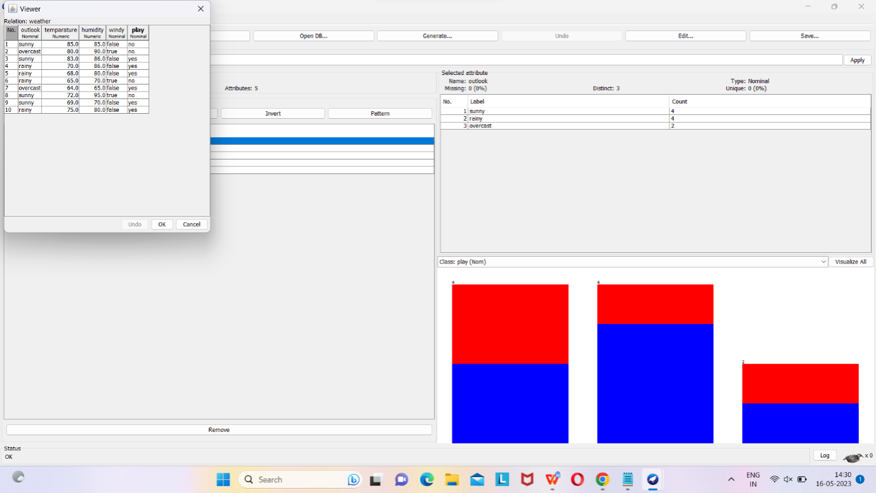

**Result:**

This program has been successfully executed.

**EXPERIMENT NO: 2**

**AIM :**

**Create an Employee Table with the help of Data Mining Tool WEKA**

**PROGRAM:**

**@relation employee**

**@attribute name {x,y,z,a,b}**

**@attribute id numeric**

**@attribute salary {low,medium,high}**

**@attribute exp numeric**

**@attribute gender {male,female**

**@attribute phone numeric**

**@data**

**x,101,low,2,male,250311**

**y,102,high,3,female,251665**

**z,103,medium,1,male,240238**

**a,104,low,5,female,200200**

**b,105,high,2,male,240240**

**OUTPUT:**

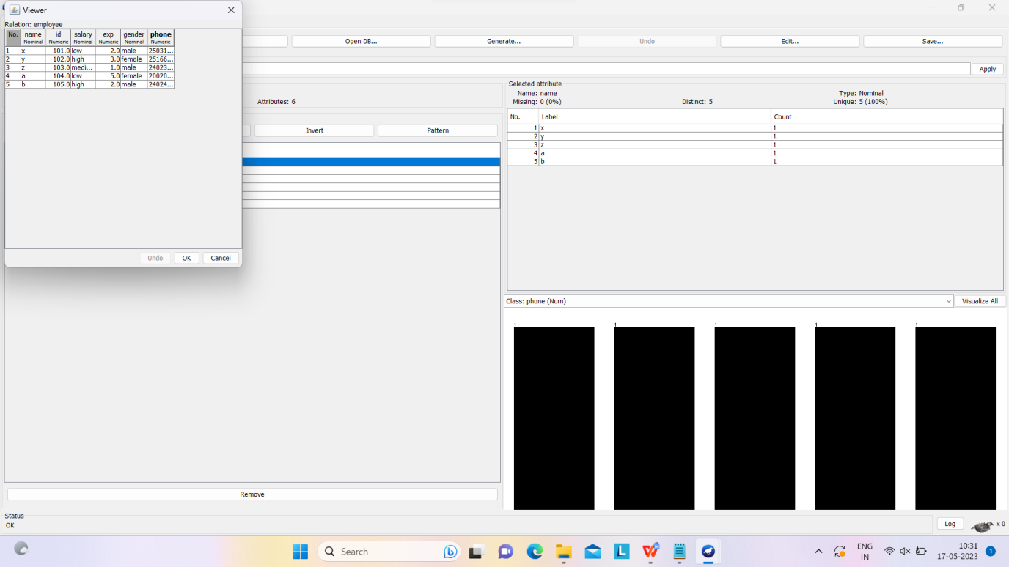

**RESULT:**

This program has been successfully executed

**EXPERIMENT NO: 3**

**AIM :**

**Create an weather Table with the help of Data Mining Tool WEKA.**

**PROGRAM:**

**@relation weather**

**@attribute outlook {sunny,rainy,overcast}**

**@attribute temparature numeric**

**@attribute humidity numeric**

**@attribute windy {true,false}**

**@attribute play {yes,no}**

**@data**

**sunny,85.0,85.0,false,no**

**overcast,80.0,90.0,true,no**

**sunny,83.0,86.0,false,yes**

**rainy,70.0,86.0,false,yes**

**rainy,68.0,80.0,false,yes**

**rainy,65.0,70.0,true,no**

**overcast,64.0,65.0,false,yes**

**sunny,72.0,95.0,true,no**

**sunny,69.0,70.0,false,yes**

**rainy,75.0,80.0,false,yes**

**OUTPUT:**

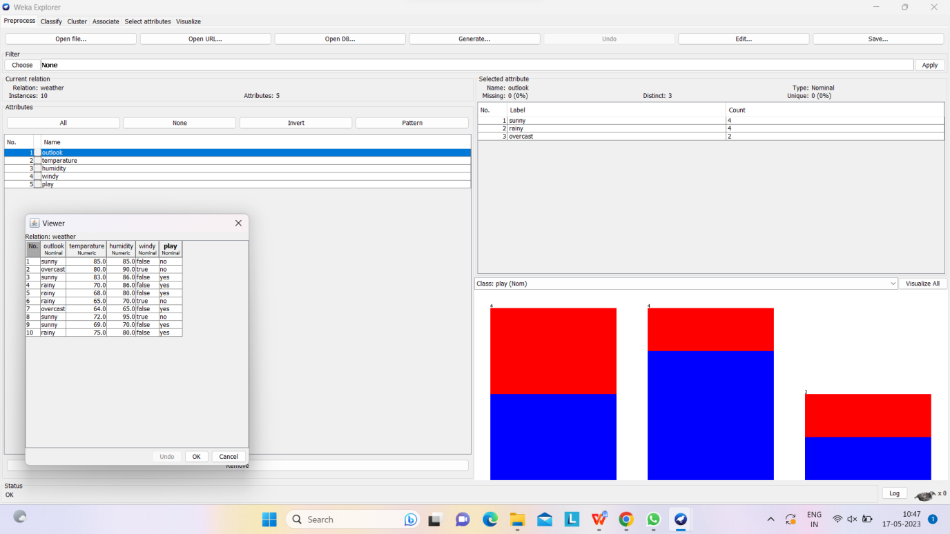

#### Add Pre-Processing Technique:

#### 

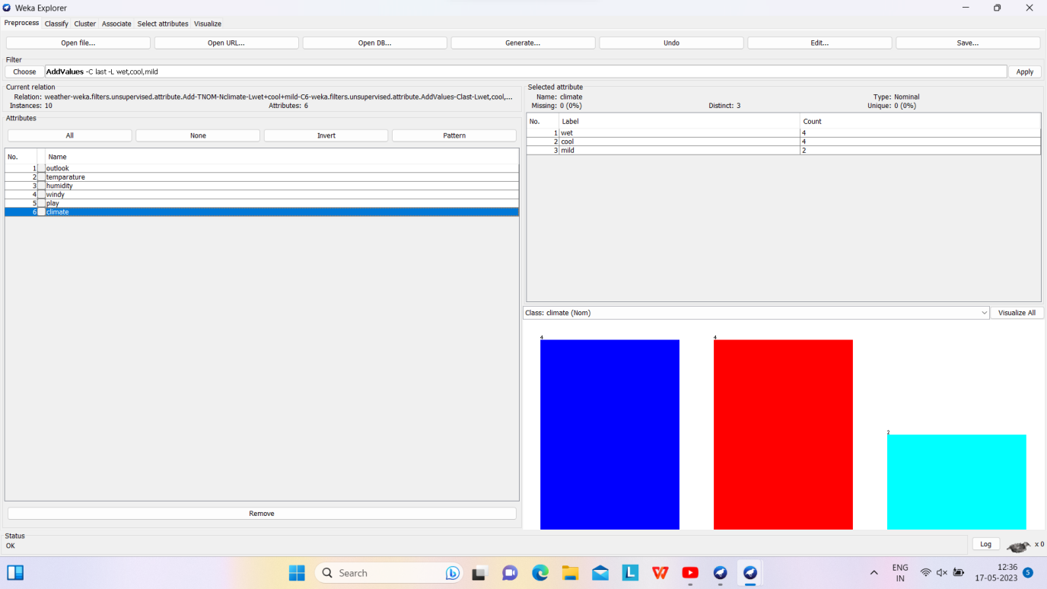

**Weather Table after removing attributes WINDY, PLAY:**

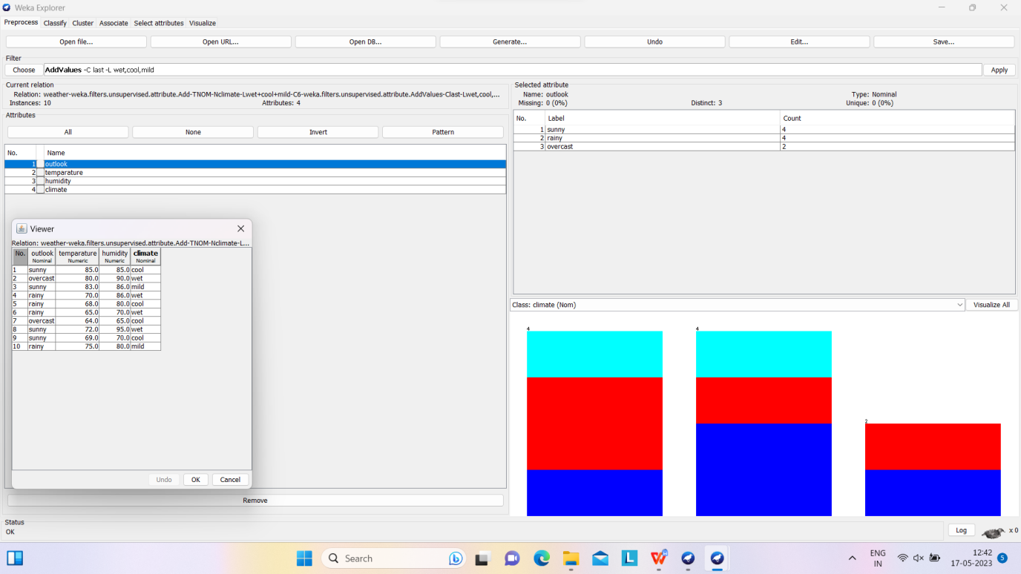

**Weather Table after Normalizin TEMPARATURE,HUMIDITY:**

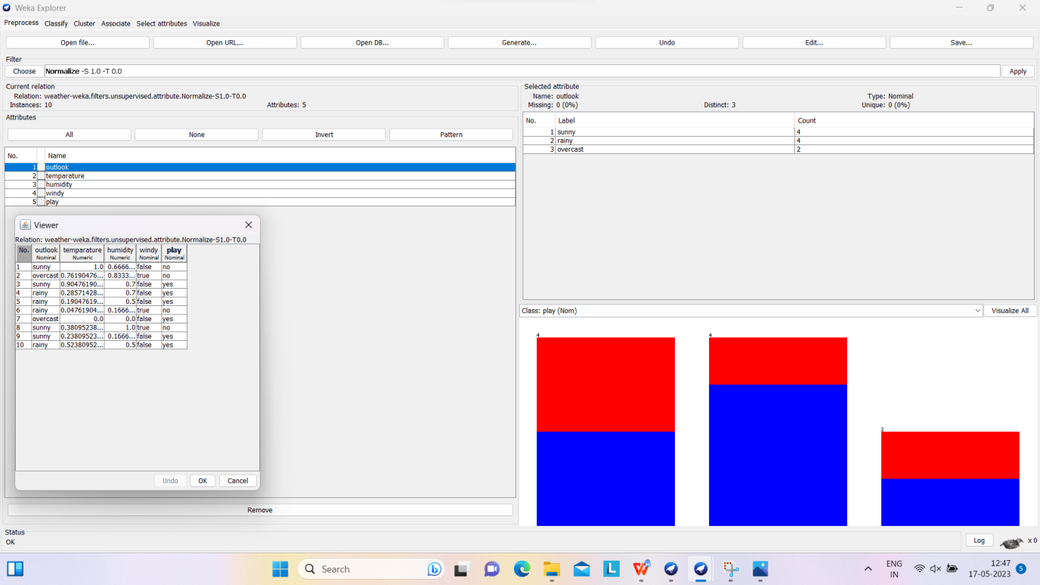

**RESULT:**

This program has been successfully executed

**EXPERIMENT NO: 4**

**AIM:**

**Apply Pre-Processing techniques to the training data set of**

**Employee Table**

**PROGRAM:**

**@relation employee**

**@attribute name {x,y,z,a,b}**

**@attribute id numeric**

**@attribute salary {low,medium,high}**

**@attribute exp numeric**

**@attribute gender {male,female}**

**@attribute phone numeric**

**@data**

**x,101,low,2,male,250311**

**y,102,high,3,female,251665**

**z,103,medium,1,male,240238**

**a,104,low,5,female,200200**

**b,105,high,2,male,240240**

**Training Data Set → Employee Table**

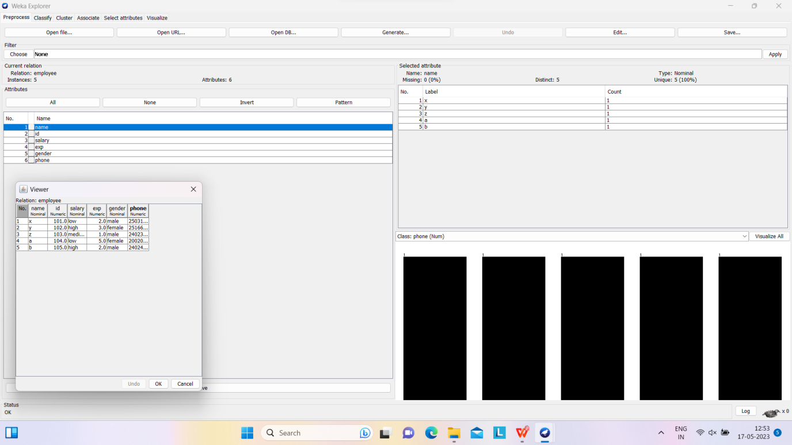

**Employee Table after adding new attribute ADDRESS:**

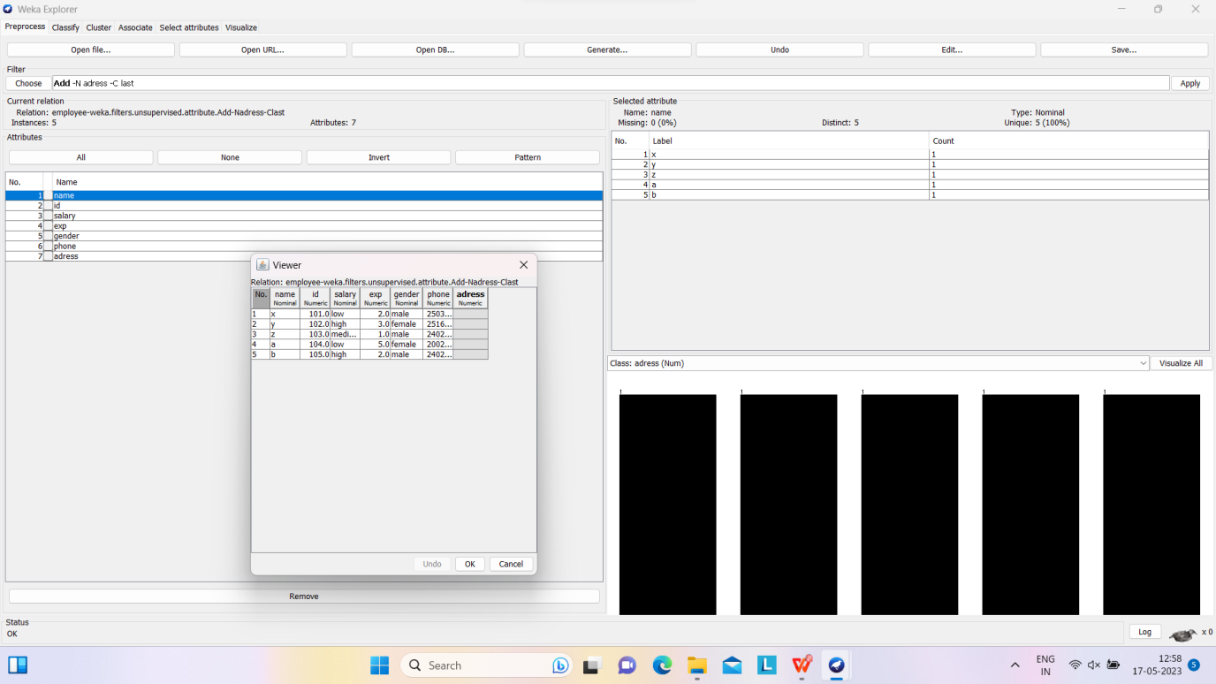

**Employee Table after removing attributes SALARY, GENDER:** 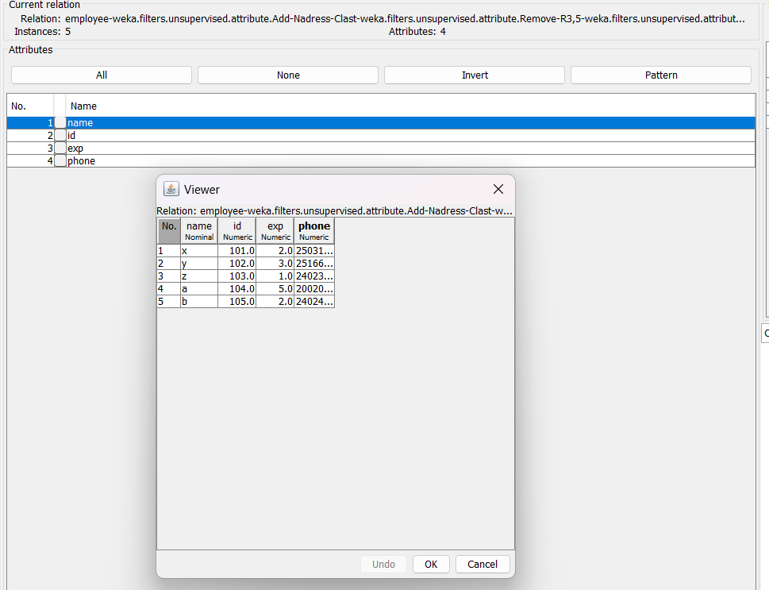

**Normalize → Pre-Processing Technique:**

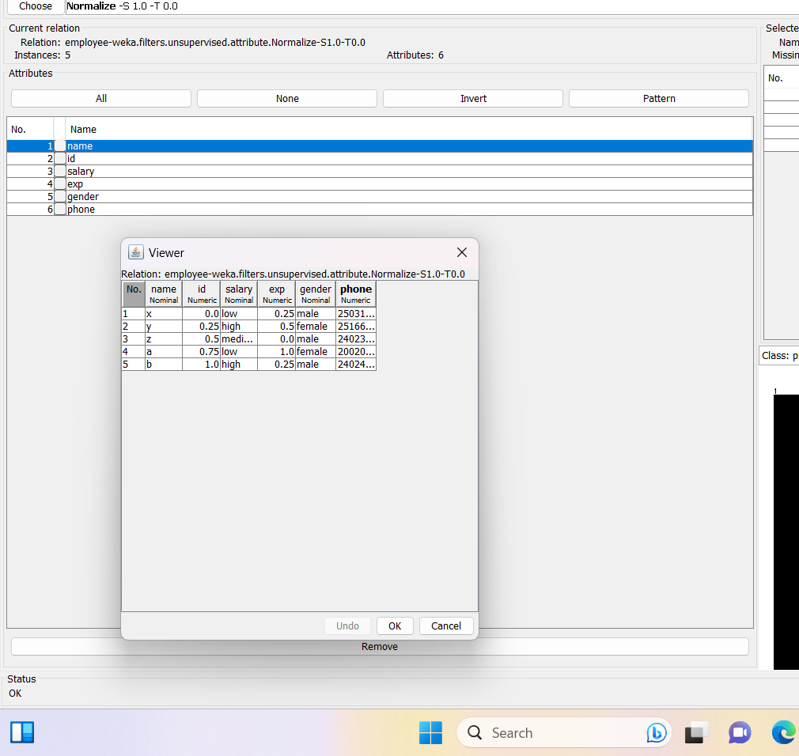

**Result:**

This program has been successfully executed

**EXPERIMENT NO:5**

**AIM:**

Normalize Weather Table data using Knowledge Flow.

**Creation of Weather Table:**

**PROGRAM:**

**@relation weather**

**@attribute outlook {sunny,rainy,overcast}**

**@attribute temparature numeric**

**@attribute humidity numeric**

**@attribute windy {true,false}**

**@attribute play {yes,no}**

**@data**

**sunny,85.0,85.0,false,no**

**overcast,80.0,90.0,true,no**

**sunny,83.0,86.0,false,yes**

**rainy,70.0,86.0,false,yes**

**rainy,68.0,80.0,false,yes**

**rainy,65.0,70.0,true,no**

**overcast,64.0,65.0,false,yes**

**sunny,72.0,95.0,true,no**

**sunny,69.0,70.0,false,yes**

**rainy,75.0,80.0,false,yes**

**Output:**

**Training Data Set → Weather Table**

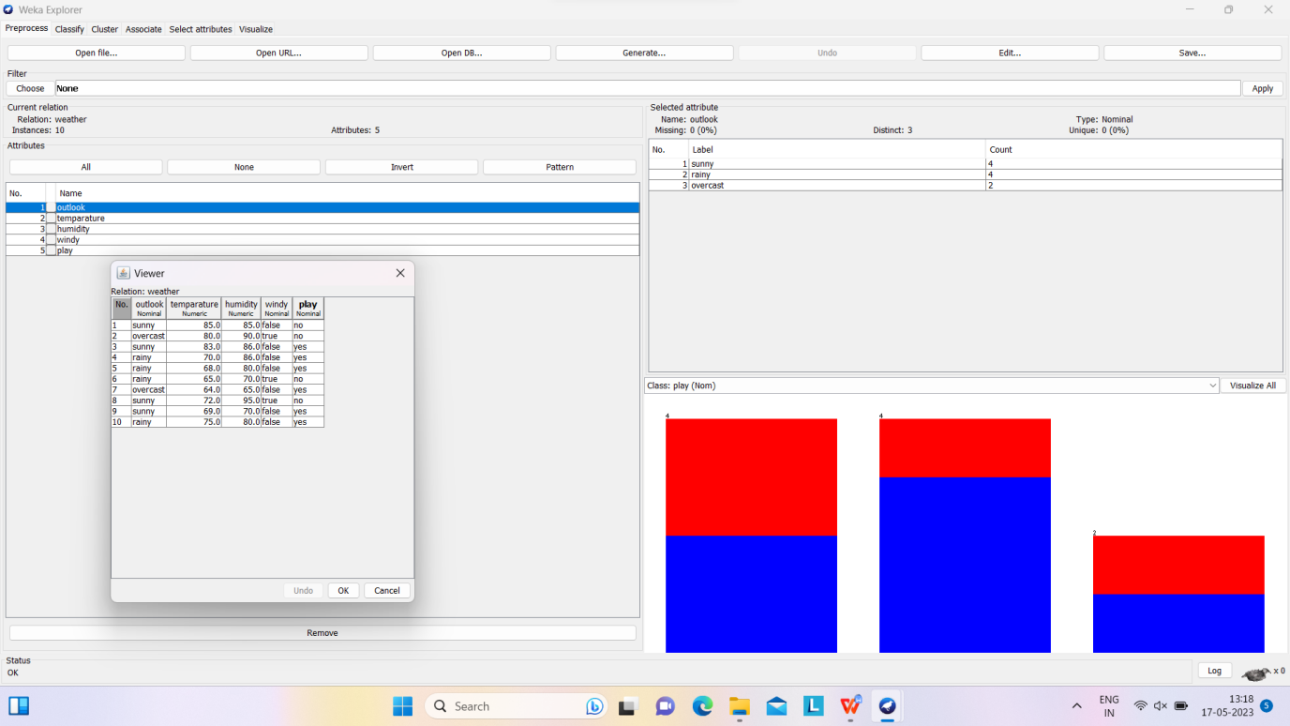

**Procedure for Knowledge Flow:**

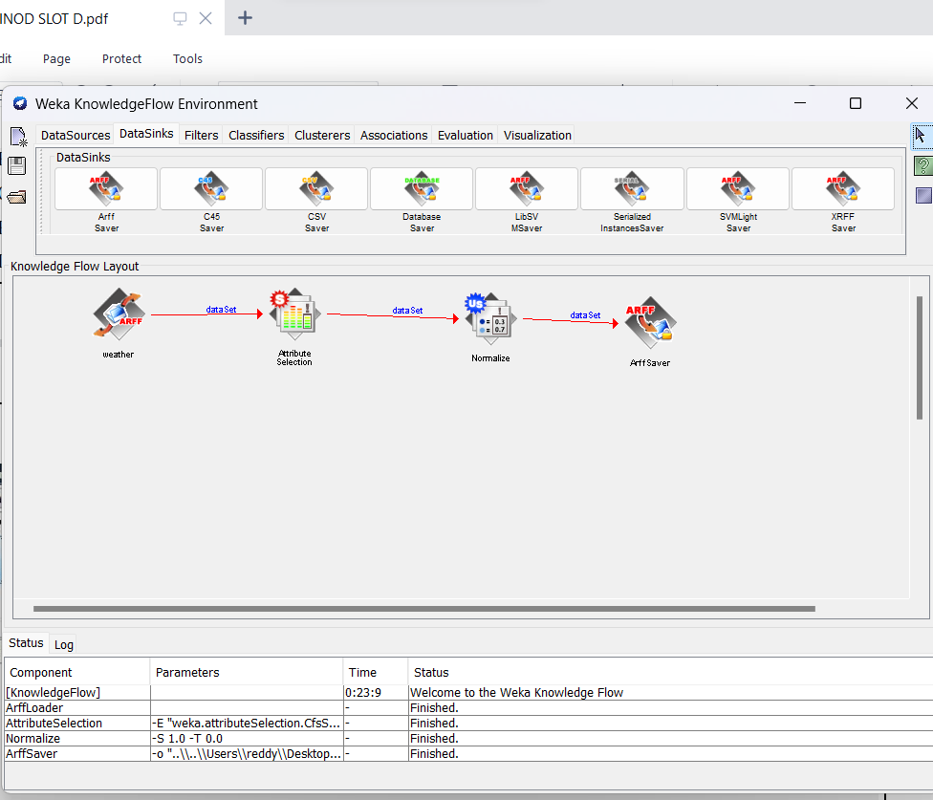**Result:**

This program has been successfully executed

**EXPERIMENT NO:6**

**AIM:**

Finding Association Rules for Buying data.

**Creation of Buying Table:**

**PROGRAM:**

@relation buying

@attribute age {L20,20-40,G40}

@attribute income {high,medium,low}

@attribute stud {yes,no}

@attribute creditrate {fair,excellent}

@attribute buyscomp {yes,no}

@data

L20,high,no,fair,yes

20-40,low,yes,fair,yes

G40,medium,yes,fair,yes

L20,low,no,fair,no

G40,high,no,excellent,yes

L20,low,yes,fair,yes

20-40,high,yes,excellent,no

G40,low,no,fair,yes

L20,high,yes,excellent,yes

G40,high,no,fair,yes

L20,low,yes,excellent,no

G40,high,yes,excellent,no

20-40,medium,yes,excellent,yes

L20,medium,yes,fair,yes

G40,high,yes,excellent,yes

**Output:**

**Training Data Set → Buying Table**

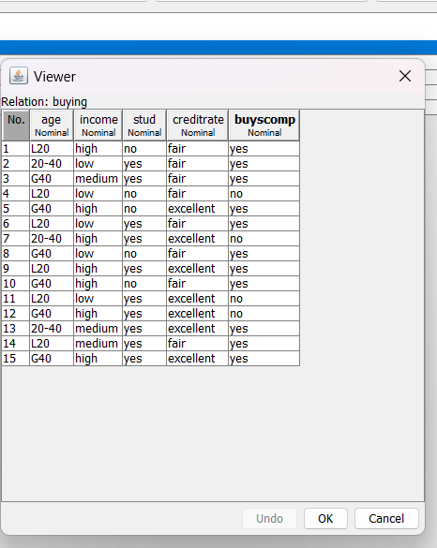

**Procedure for Association Rules:**

**1)** Open Start → Programs → Weka-3-4 → Weka-3-4

**2)** Open **explorer**.

**3)** Click on **open file** and select **buying.arff**

**4)** Select **Associate option** on the top of the Menu bar.

**5)** Select **Choose button** and then click on **Apriori Algorithm**.

**6)** Click on **Start button** and output will be displayed on the **right side** of the window

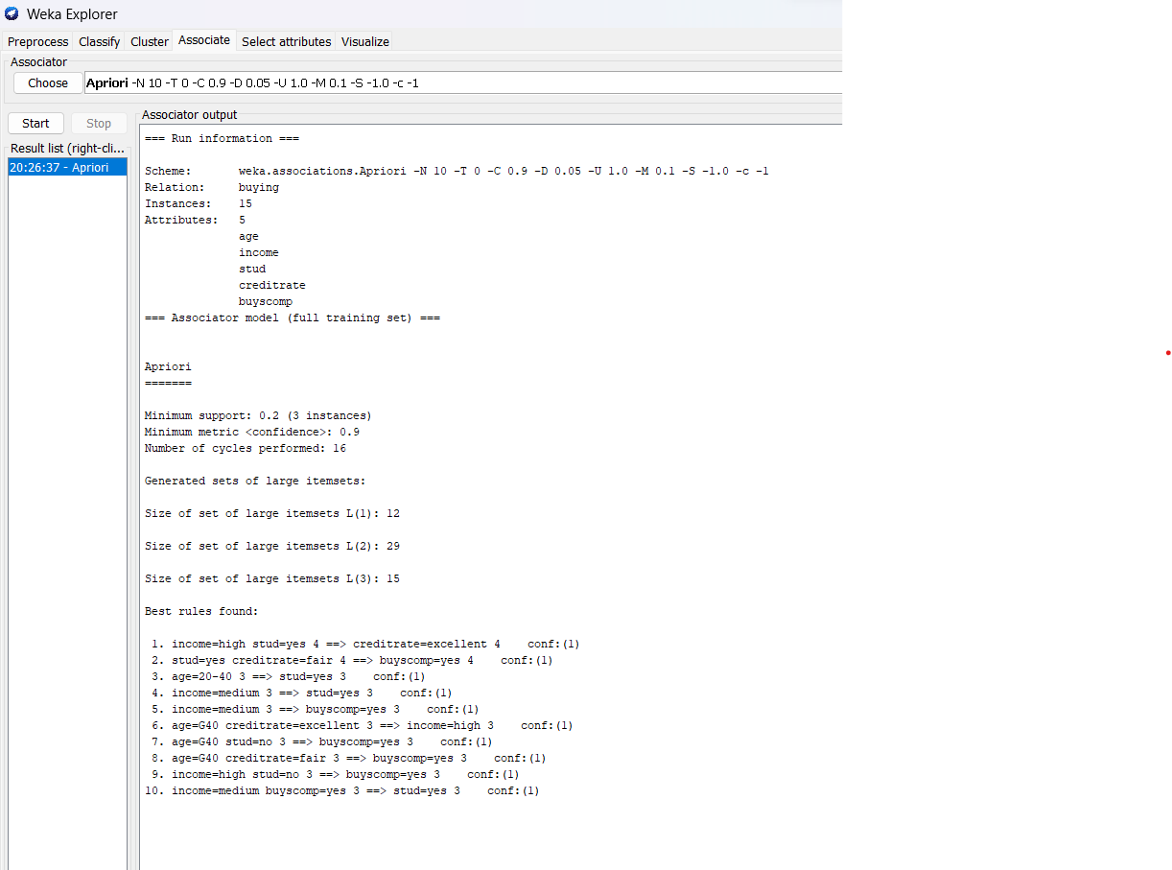

**Result:**

This program has been successfully

**EXPERIMENT NO:7**

**AIM:**

Finding Association Rules for Banking data.

**Creation of Banking Table:**

**Procedure:**

**@relation bank**

**@attribute cust {male,female}**

**@attribute accno {0101,0102,0103,0104,0105,0106,0107,0108,0109,0110,0111,0112,0113,0114,0115}**

**@attribute bankname {sbi,hdfc,sbh,ab,rbi}**

**@attribute location {hyd,jmd,antp,pdtr,kdp}**

**@attribute deposit {yes,no}**

**@data**

**male,0101,sbi,hyd,yes**

**female,0102,hdfc,jmd,no**

**male,0103,sbh,antp,yes**

**male,0104,ab,pdtr,yes**

**female,0105,sbi,jmd,no**

**male,0106,ab,hyd,yes**

**female,0107,rbi,jmd,yes**

**female,0108,hdfc,kdp,no**

**male,0109,sbh,kdp,yes**

**male,0110,ab,jmd,no**

**female,0111,rbi,kdp,yes**

**male,0112,sbi,jmd,yes**

**female,0113,rbi,antp,no**

**male,0114,hdfc,pdtr,yes**

**female,0115,sbh,pdtr,no**

**Training Data Set → Banking Table:**

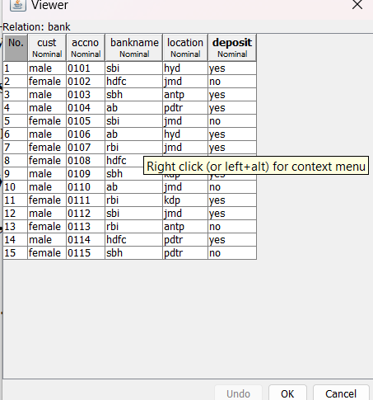

**Procedure for Association Rules:**

**1)** Open Start → Programs → Weka-3-4 → Weka-3-4

**2)** Open **explorer**.

**3)** Click on **open file** and select **bank.arff**

**4)** Select **Associate option** on the top of the Menu bar.

**5)** Select **Choose button** and then click on **Apriori Algorithm**.

**6)** Click on **Start button** and output will be displayed on the **right side** of the window

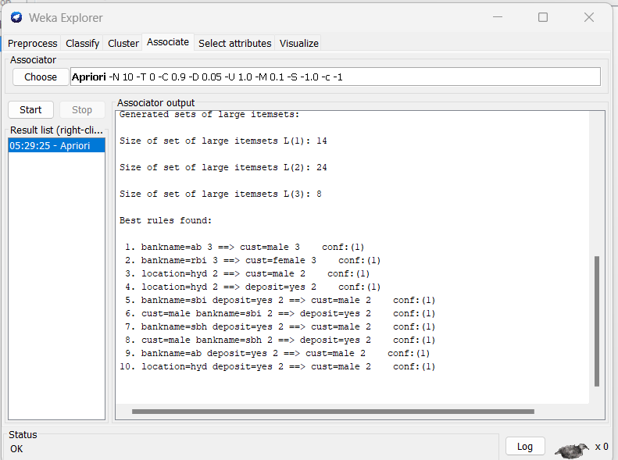

**Result:**

This program has been successfully executed.

**EXPERIMENT NO:8**

**AIM:**

Finding Association Rules for Employee data.

**Creation of Banking Table:**

**Program:**

**@relation employee-1**

**@attribute age {youth, middle, senior}**

**@attribute income {high, medium, low}**

**@attribute class {A, B, C}**

**@data**

**youth, high, A**

**youth,medium,B**

**youth, low, C**

**middle, low, C**

**middle, medium, C**

**middle, high, A**

**senior, low, C**

**senior, medium, B**

**senior, high, B**

**middle, high, B**

**Training Data Set → Employee Table**

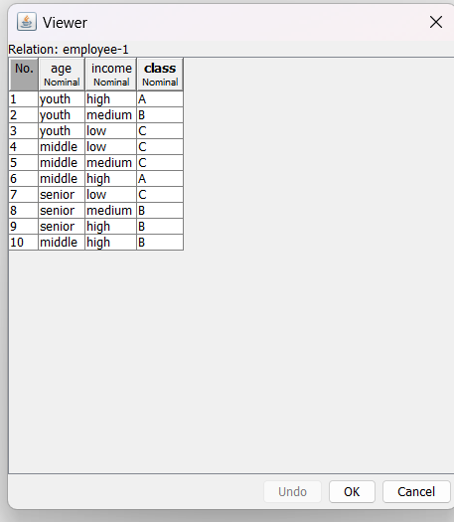

**Procedure for Association Rules:**

1) Open Start → Programs → Weka-3-4 → Weka-3-4

2) Open **explorer**.

3) Click on **open file** and select **employee-1.arff**

4) Select **Associate option** on the top of the Menu bar.

5) Select **Choose button** and then click on **Apriori Algorithm**.

6) Click on **Start button** and output will be displayed on the **right side** of the window

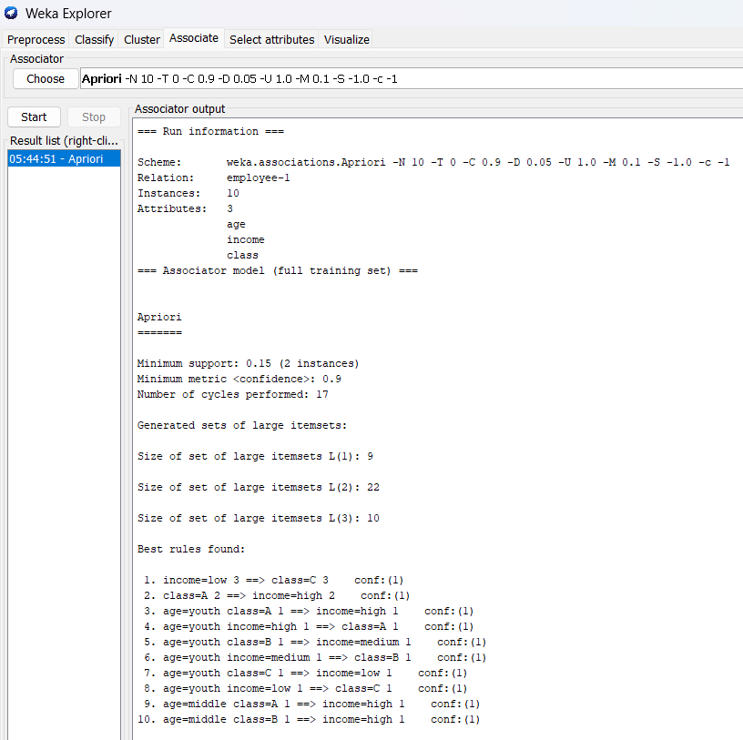

**RESULT:**

This program has been successfully executed.

**EXPERIMENT NO:9**

**AIM:**

To Construct Decision Tree for Weather data and classify it.

**Creation of Weather Table:**

**PROGRAM:**

@relation weather

@attribute outlook {sunny, rainy, overcast}

@attribute temperature numeric

@attribute humidity numeric

@attribute windy {TRUE, FALSE}

@attribute play {yes, no}

@data

sunny,85,85,FALSE,no

sunny,80,90,TRUE,no

overcast,83,86,FALSE,yes

rainy,70,96,FALSE,yes

rainy,68,80,FALSE,yes

rainy,65,70,TRUE,no

overcast,64,65,TRUE,yes

sunny,72,95,FALSE,no

sunny,69,70,FALSE,yes

rainy,75,80,FALSE,yes

sunny,75,70,TRUE,yes

overcast,72,90,TRUE,yes

overcast,81,75,FALSE,yes

rainy,71,91,TRUE,no

**Training Data Set → Weather Table**

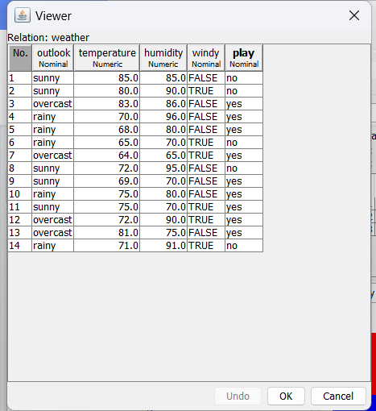

**Procedure for Decision Trees:**

**1)** Open Start → Programs → Weka-3-4 → Weka-3-4

**2)** Open **explorer**.

**3)** Click on **open file** and select **weather.arff**

**4)** Select **Classifier option** on the top of the Menu bar.

**5)** Select **Choose button** and click on **Tree option**.

**6)** Click on **J48.**

**7)** Click on **Start button** and output will be displayed on the **right side** of the window.

**8)** Select the **result list** and **right click** on result list and select **Visualize Tree option**.

**9)** Then **Decision Tree** will be displayed on **new window**.

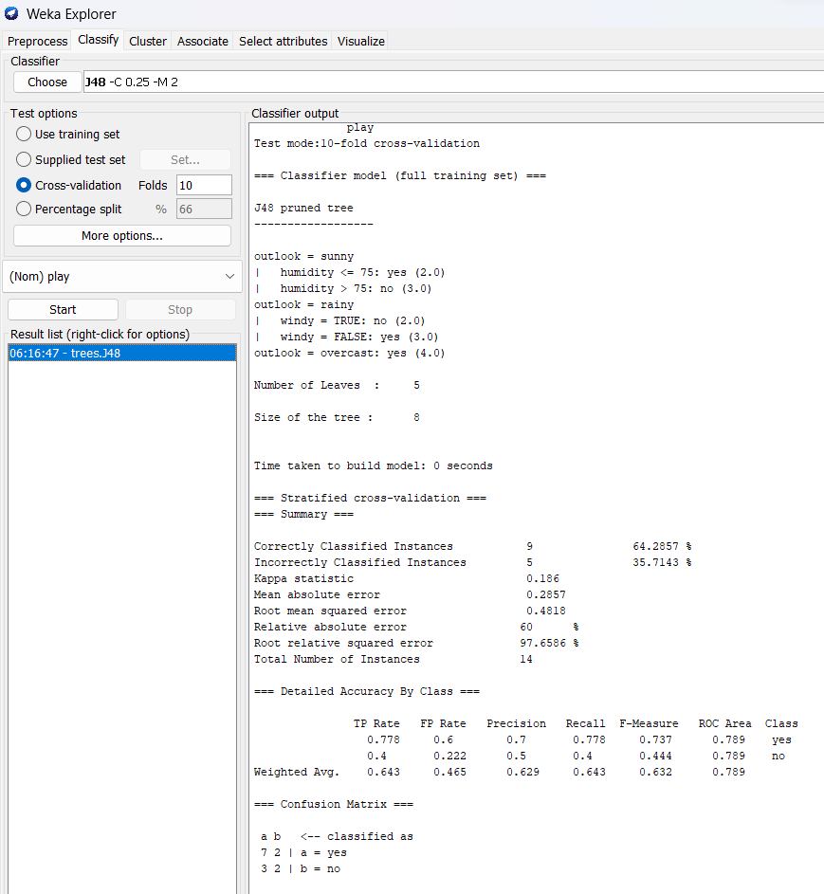

**Decision Tree:**

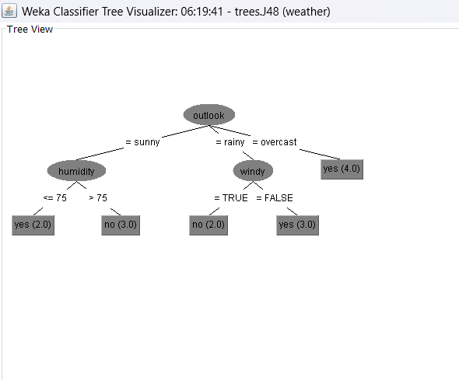

**Result:**

This program has been successfully executed.

**EXPERIMENT NO:10**

**AIM:**

Normalize Employee Table data using Knowledge Flow.

**Creation of Employee Table:**

**PROGRAM:**

@relation employee

@attribute eid numeric

@attribute ename {raj,ramu,anil,sunil,rajiv,sunitha,kavitha,suresh,ravi,ramana,ram,kavya,navya}

@attribute salary numeric

@attribute exp numeric

@attribute address {pdtr,kdp,nlr,gtr}

@data

101,raj,10000,4,pdtr

102,ramu,15000,5,pdtr

103,anil,12000,3,kdp

104,sunil,13000,3,kdp

105,rajiv,16000,6,kdp

106,sunitha,15000,5,nlr

107,kavitha,12000,3,nlr

108,suresh,11000,5,gtr

109,ravi,12000,3,gtr

110,ramana,11000,5,gtr

111,ram,12000,3,kdp

112,kavya,13000,4,kdp

113,navya,14000,5,kdp

**Output:**

**Training Data Set → Employee Table**

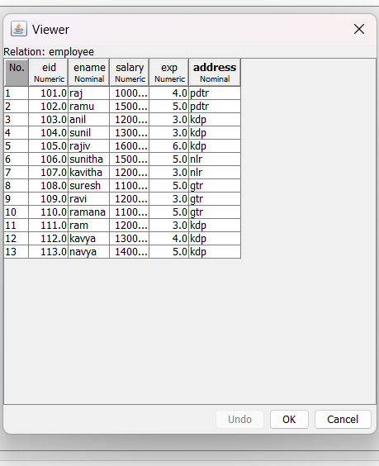

**Procedure for Knowledge Flow:**

**1)** Open Start → Programs → Weka-3-4 → Weka-3-4

**2)** Open the **Knowledge Flow**.

**3)** Select the **Data Source component** and **add Arff Loader** into the **knowledge layout canvas**.

**4)** Select the **Filters component** and **add Attribute Selection** and N**ormalize** into the knowledge layout canvas.

**5)** Select the **Data Sinks** component and **add Arff Saver** into the knowledge layout canvas.

**6)** Right click on **Arff Loader** and select **Configure option** then the new window will be opened and select

**Employee.arff**

**7)** Right click on **Arff Loader** and select **Dataset option** then establish a link between **Arff Loader** and

A**ttribute Selection**.

**8)** Right click on **Attribute Selection** and select **Dataset option** then establish a link between **Attribute**

**Selection** and **Normalize**.

**9)** Right click on **Attribute Selection** and select **Configure option** and choose the best attribute for Employee

data.

**10)** Right click on **Normalize** and select **Dataset option** then establish a link between **Normalize** and **Arff Saver**.

**11)** Right click on **Arff Saver** and select **Configure option** then new window will be opened and set the path,

enter **.arff** in look in dialog box to save normalize data.

**12)** Right click on **Arff Loader** and click on **Start Loading option** then everything will be executed one by one.21

**13)** Check whether output is created or not by selecting the preferred path.

**14)** Rename the data name as **a.arff**

**15)** Double click on **a.arff** then automatically the output will be opened in **MS-Excel**

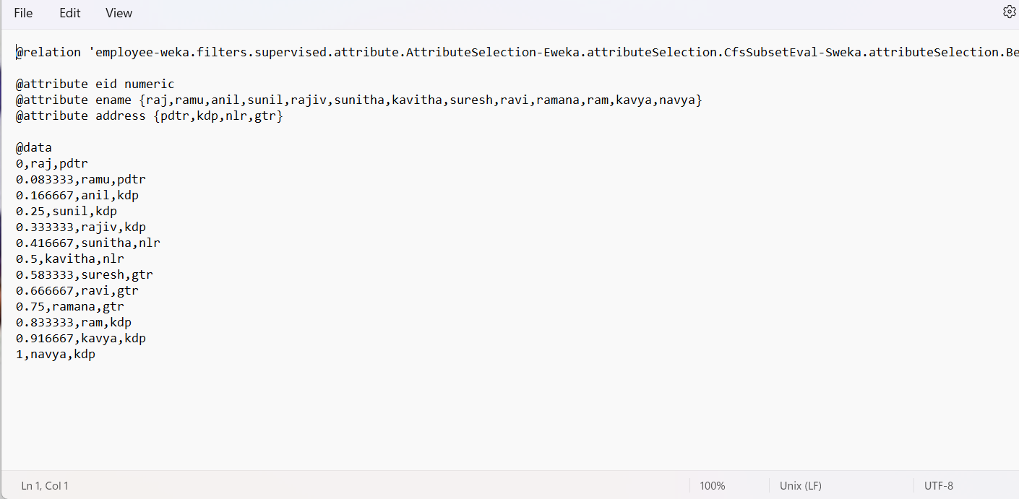

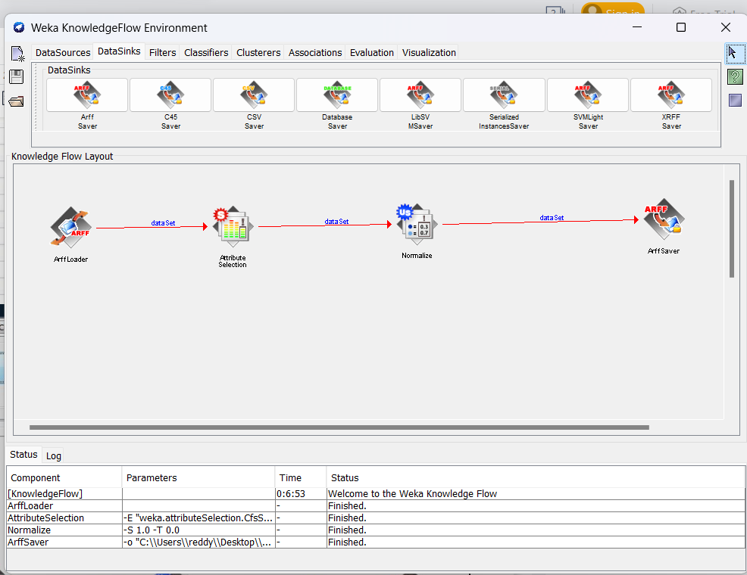

**RESULT:**

This program has been successfully executed